Name : Saurabh Jadhav

Topic: Git Branch

Assignment no. : 2

1. Launch EC2 instance and connect to it.
2. Create files and directories and push them to repo.

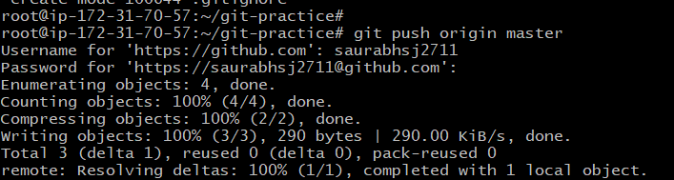

1. Create branch “aws” and go to it.

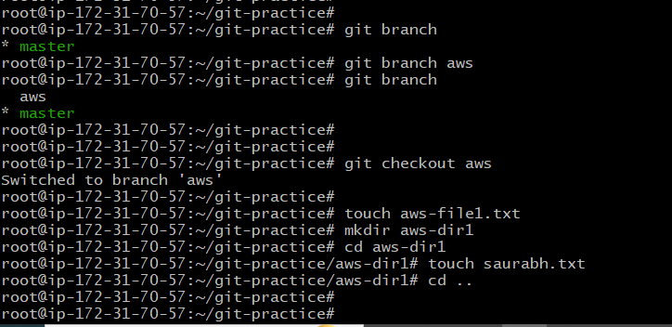

1. But we can see that if files and directories are in working directory then we can view them from all branches.

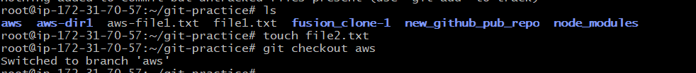

1. Commit the files and dir to local repo.

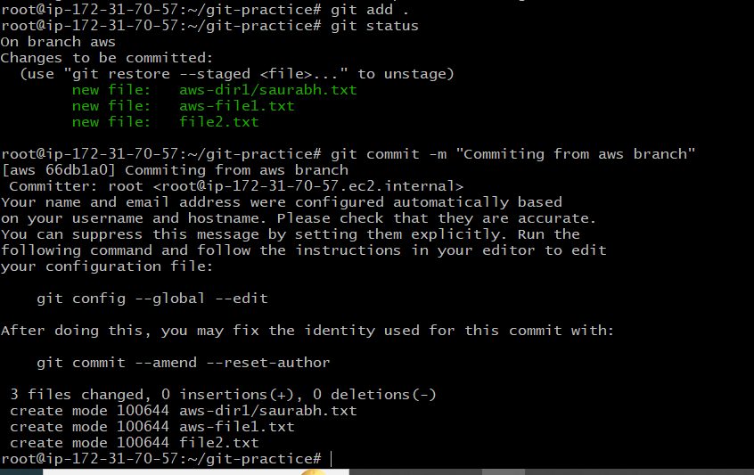

1. Push the repo to remote repo using aws branch.

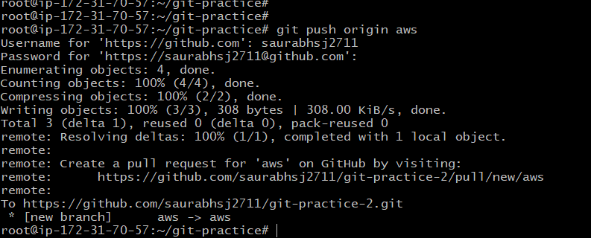

1. Hence we can view the files and dir in aws branch.

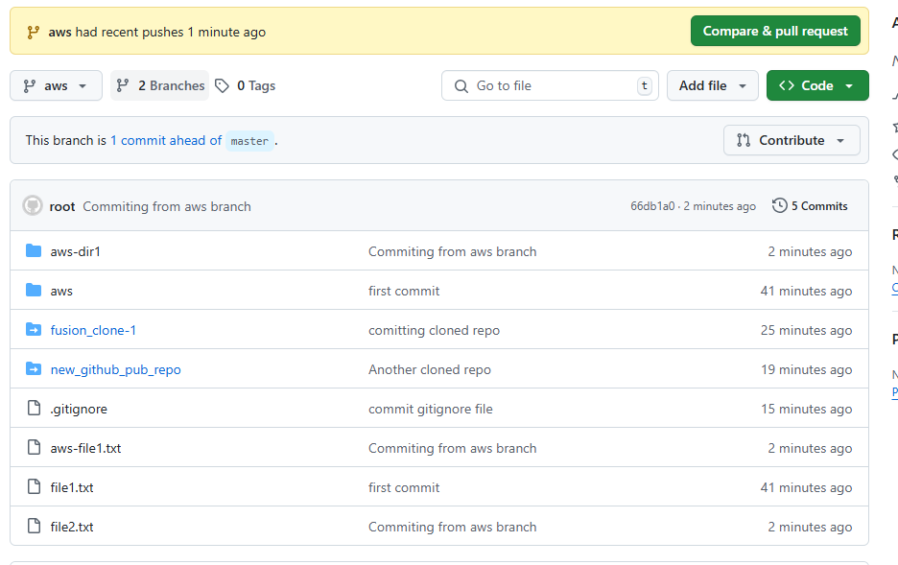

1. Now we will make another branch devops to aws branch. Create files using it.

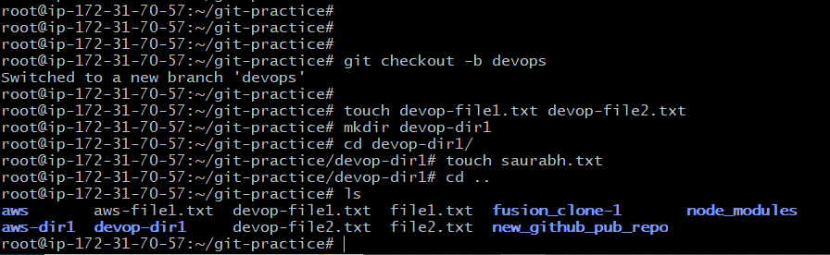

1. Commit and push the files to repo using devops branch.

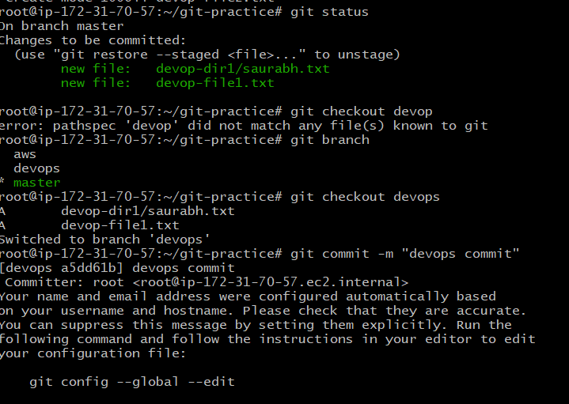

1. Merge Devops repo to master repo.

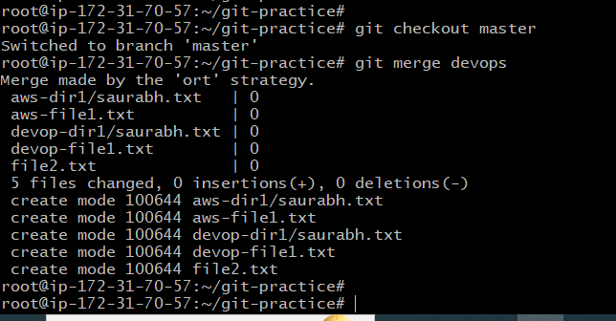

1. Delete branch

